Name:Kothmirkar Keerthan
Hall Ticket:2303A52008
Batch:43 Assginment:9.1
Task : 01
Consider the following Python function:
def find_max(numbers):
return max(numbers) Task:
- Write documentation for the function in all three formats:
- Docstring
- Inline comments
- Google-style documentation
- Critically compare the three approaches. Discuss the advantages, disadvantages, and suitable use cases of each style.
- Recommend which documentation style is most effective
for a mathematical utilities library and justify your answer.
Prompt:for this code implement the documentations Code:

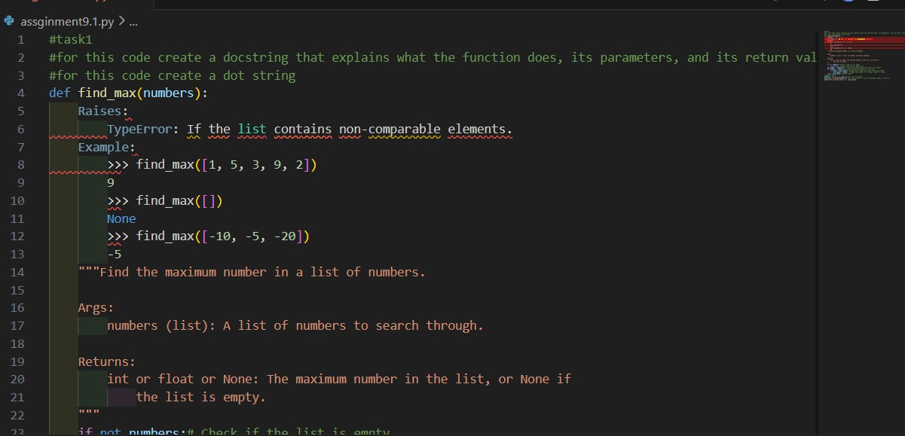
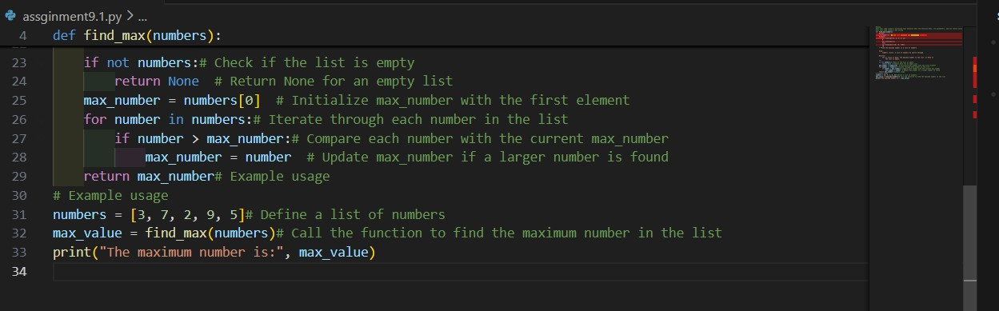
Observations:
Docstrings provide quick in-code documentation and are best for simple understanding, while inline comments explain logic step-by- step but can clutter the code.
Google-style documentation is more structured, readable, and suitable for large projects because it clearly defines parameters, returns, and behavior.
For a mathematical utilities library, Google-style documentation is most effective since it ensures consistency, clarity, and professional maintainability across many functions.
Task2:
Problem 2: Consider the following Python function: def login(user, password, credentials):

return credentials.get(user) == password Task:
- Write documentation in all three formats.
- Critically compare the approaches.
- Recommend which style would be most helpful for new developers onboarding a project, and justify your choice. Prompt: for this code impment three documentations Code:
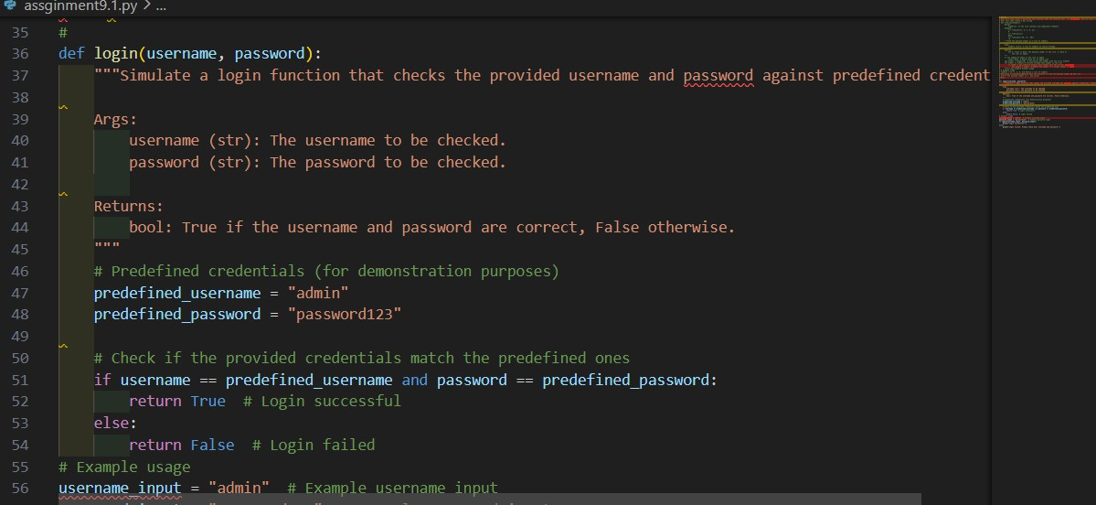
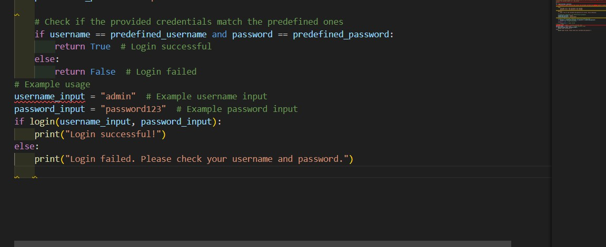

OUTPUT:

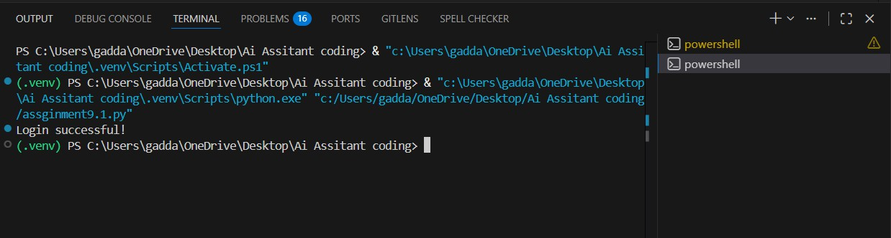
Observation:
Inline comments help beginners understand each step of the login logic but may make the code look crowded if overused.
Docstrings summarize the function’s purpose and usage clearly,
making them useful for quick reference within the code.
Google-style documentation is most helpful for onboarding new developers because it systematically explains inputs, outputs, and behavior, improving readability and maintainability
Task:03
Problem 3: Calculator (Automatic Documentation Generation) Task: Design a Python module named calculator.py and demonstrate automatic documentation generation.
Instructions:
- Create a Python module calculator.py that includes the following functions, each written with appropriate docstrings:
o add(a, b) – returns the sum of two numbers
o subtract(a, b) – returns the difference of two numbers
o multiply(a, b) – returns the product of two numbers
o divide(a, b) – returns the quotient of two numbers

- Display the module documentation in the terminal using
Python’s documentation tools.
- Generate and export the module documentation in HTML format using the pydoc utility, and open the generated HTML file in a web browser to verify the output.
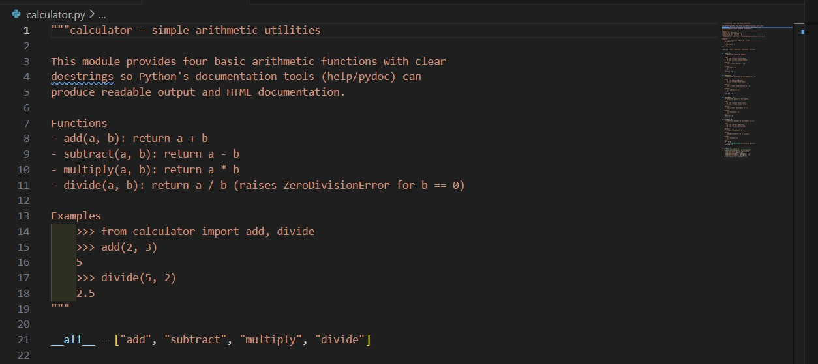
Prompot: for this implement code for the calculateCode:

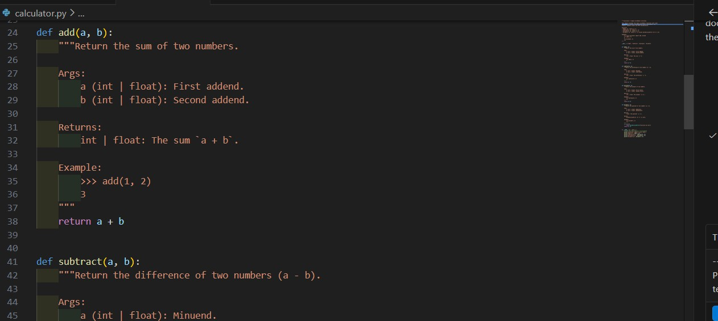
Output:


Observation:
Well-written docstrings enable automatic documentation generation tools like pydoc to produce clear module descriptions without extra effort.
Terminal documentation allows quick inspection during development, while HTML output provides a structured, shareable reference.
Automatic documentation improves consistency, reduces manual work, and is especially useful for maintaining reusable modules like a calculator library.

Task:04
Write a module named conversion.py with functions:
o decimal_to_binary(n)
o binary_to_decimal(b)
o decimal_to_hexadecimal(n)
- Use Copilot for auto-generating docstrings.
- Generate documentation in the terminal.
- Export the documentation in HTML format and open it in a

Browser
Prompt: for this code implement the user conversion Code:
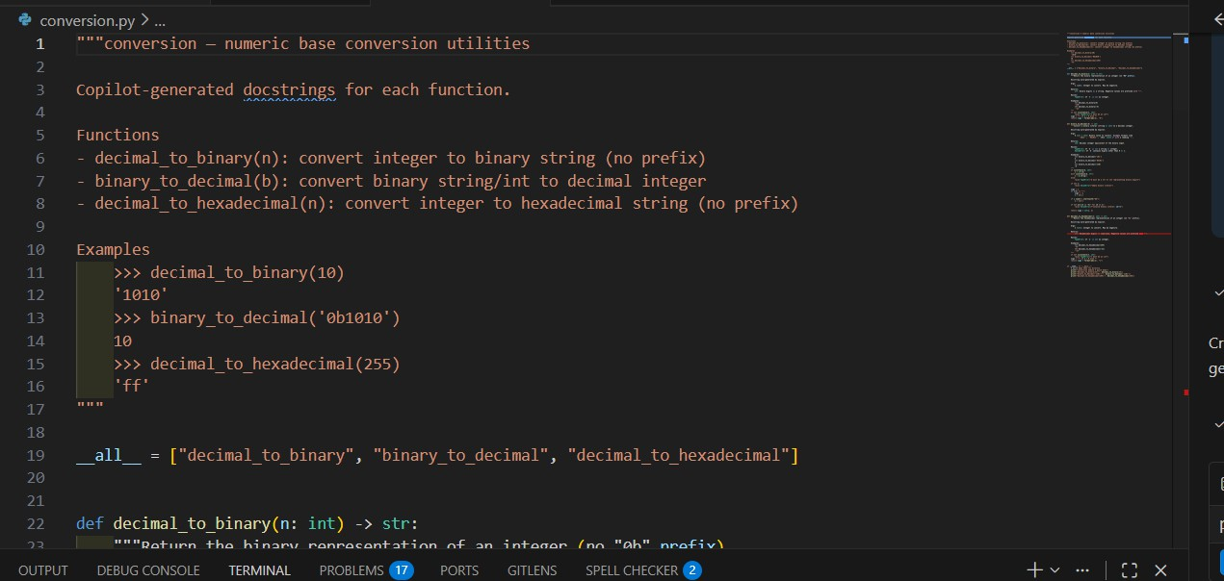
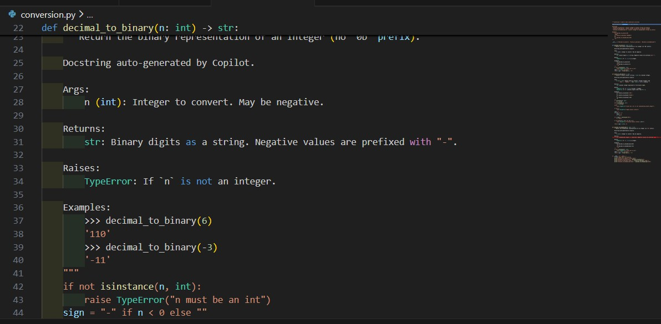
Output:
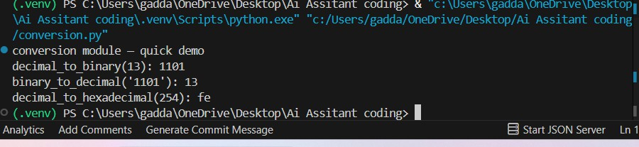

Observation:
Auto-generated docstrings (e.g., via Copilot) speed up development but should be reviewed for accuracy and clarity.
Terminal documentation provides quick access for developers, while HTML output offers a well-organized, user-friendly reference.
Automatic documentation ensures consistency and is highly beneficial for utility modules that may be reused across multiple projects.
Task 05:
Course Management Module Task:
- Create a module course.py with functions:
o add_course(course_id, name, credits)
o remove_course(course_id)
o get_course(course_id)
- Add docstrings with Copilot.
- Generate documentation in the terminal.
- Export the documentation in HTML format and open it in a browser
prompt: for this generate the course management for all three documentation

Code

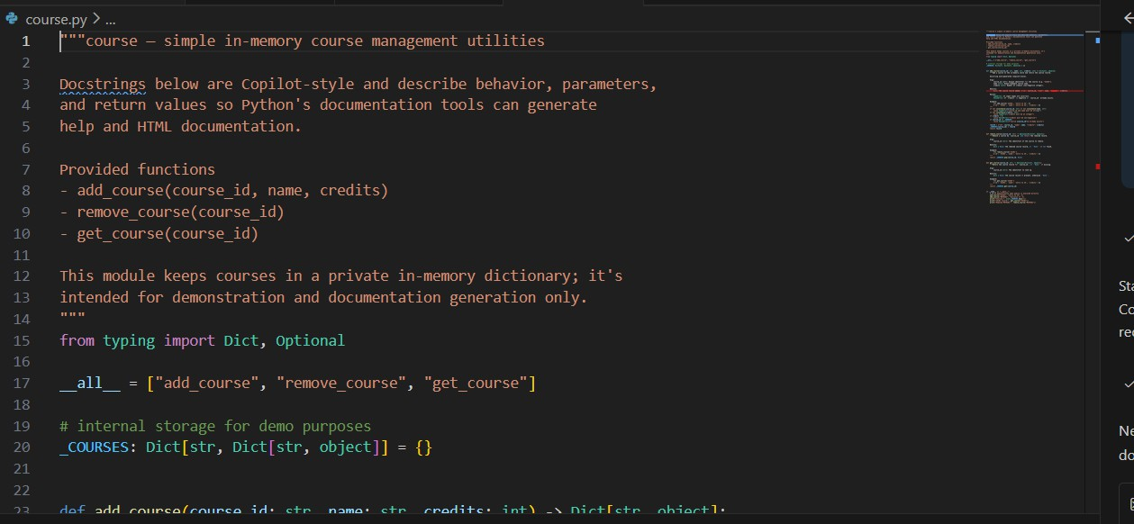
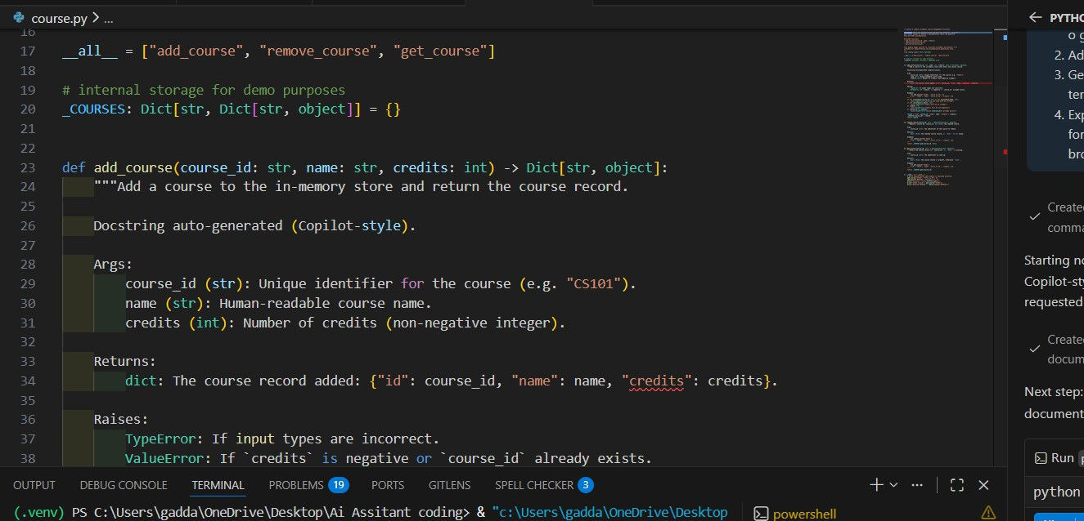
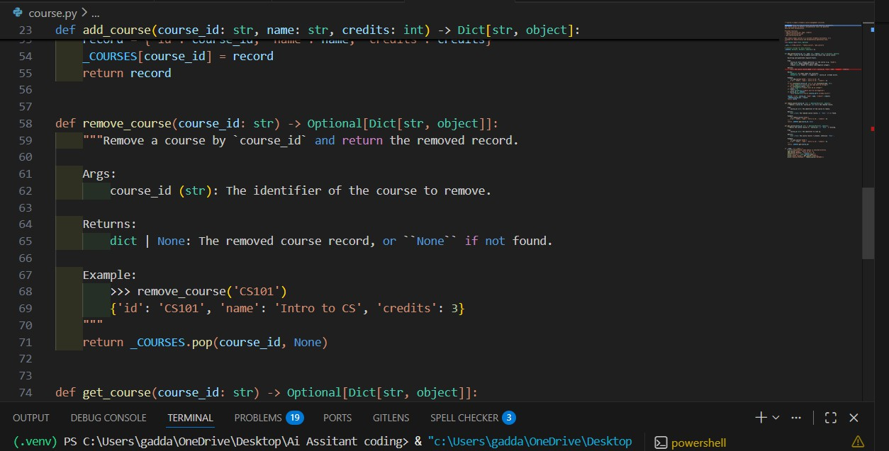

Output:

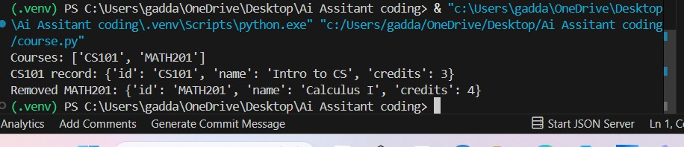
Observations:
Copilot-generated docstrings help quickly document course management functions but should be validated to ensure correctness and completeness.
Terminal documentation is useful for developers during coding, whereas HTML documentation provides a structured reference for broader use.
Automatic documentation improves maintainability and clarity, especially for modules that manage structured data like courses.

